Measuring Motor Stall Torque or Clutch Disengage

The long arm of the “Lever” Law

NOTE TO THE TEACHER:
In this investigation students will learn how to measure stall torque for motors or determine the point where the clutch will disengage without causing damage to the motor. The control variable in this lesson is the point where the motor stalls or the clutch disengages. Torque is the variable that will be measured. This will be accomplished by altering the amount of weight or moving the position of the weight on the lever.

Approximate classroom time: 1 to 2 periods depending on students’ background

Students will be able to:
- Apply and clarify various points of an experimental procedure:
Experimental hypothesis
Measurement technique
Multiple trials
Systematic error
Random error
- Use a ruler or tape to measure accurately to .5 inches.
- Accurately read a weight scale in both ounces and grams.
- Construct the test bed
- Collect data from the investigation
Graph results
Calculate averages
Perform conversions
- Interpolate new information from the data collected
- Write a conclusion that summarizes the lessons learned in the investigation.

Description of the investigation

Science Standards
Content Standard “A” Science as Inquiry
Content Standard “B” Physical Science
Content Standard “E” Science and Technology
Unifying Concepts

- Systems, Order, and Organization
- Evidence, Models, Explanation
- Constancy, Change, and Measurement
- Evolution and Equilibrium
Math Standards
1.
2.

Technology Standards
1.
2.

In this investigation students will:
- Apply scientific process
- Write a program that will be used to control the motor
- Build a test bed
- Move a weight along the lever enabling them to test specific conditions
- Calculate TORQUE = distance times weight (D x W = TORQUE)
- Run their investigation at least three times with each condition
- Accurately measure the results in each condition and record it
- Convert mass to metric units
- Learn relationship of weight to distance from the fulcrum
- Describe torque in terms relating to weight times distance
- Write a conclusion describing what they learned

Math Versus Science
As students complete the investigations they will begin to understand the relationship between mathematics and science. Mathematics is pure; when you plug numbers into equations you will get the same result every time. Science is dependent on multiple variables that may or may not be in control of the investigator. A good scientist will eliminate as many uncontrollable variables as possible so that they are able to analyze and measure the results of their investigation.

Experimental Error
There are many things that can cause your experimentally measured numbers to fall off-target from the predicted values. Here are a few:

- Clutch Slippage
At higher torque, the clutch slips to reduce the chance of damage to the motor. This results in a shorter distance being traveled.

- Motor temperature

- Friction

- Battery power varies due to charge level

This unit includes a worksheet where students capture data and write conclusions; on the following pages you will find the answer key for the worksheet.

Graphing Motor Stall Torque

NOTE TO THE TEACHER:

In this investigation students will learn how to measure stall torque for motors or determine the point where the clutch will disengage without causing damage to the motor. The control variable in this lesson is the point where the motor stalls or the clutch disengages. Torque is the variable that will be measured. This will be accomplished by altering the amount of weight or moving the position of the weight on the lever:

- Build a test bed – see parts list.
- Move a weight along the lever enabling them to test specific conditions
- Calculate distance times weight (D x W = TORQUE)
- Increase rotational torque ( This can cause permanent damage to the motor)
- Learn relationship of weight to distance from the fulcrum)

LESSON 1: MEASURING STALL TORQUE FOR MOTORS

Investigation Steps

Safety glasses must be worn for this activity
Have your instructor check your setup before you power the motor
NOTE: Sometimes the motor will not lift the lever high enough to hit the bumper / limit switch. One member of the investigation team should be ready to stop the investigation by hitting the switch.

Condition 1
- Gather investigation instructions, tools, and parts.
- Build the test bed pictured at the right.
- Place the weight holding device 7 inches from the fulcrum.
- Measure from the fulcrum to the hole, record distance.
- Add on to two ounces of weight to the weight holding device at the end of the lever arm.
- Cycle the test bed
- Keep adding until the motor will not lift or the clutch begins to slip.
- Remove the weight holding device.
- Measure the weight utilizing your scale.
- Record the data on the chart supplied in the worksheet.
- Repeat the experiment three times to confirm your results.
- Average your results and record your data.
- Convert the result of your test from inch / ounces into foot / pounds.
- Convert your data to Newton / centimeters

Condition 2
- Move the weight holding device two inches closer to the fulcrum.
- Repeat Steps 4 through 14 from Condition 1

Condition 3
- Move the weight holding device two inches closer to the fulcrum.
- Repeat Steps 4 through 14 from Condition 1

Extension Activity: Build a transmission utilizing different gear ratios to see how the investigation results change.

Worksheet: Graphing Motor Stall Torque

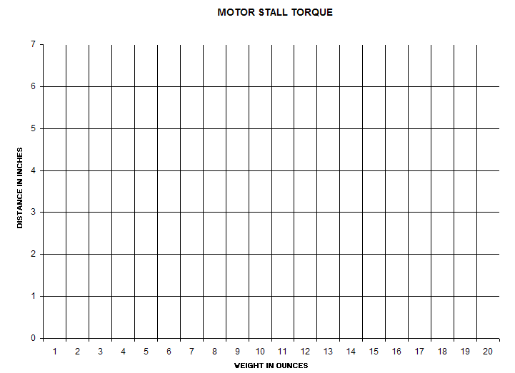

Helpful Hint:

Record each condition in a different color.

Conversion of Units: Write formulas and record results below.

Proportion: Based on data collected, calculate your average stall torque value. Use this value to estimate the amount of mass your motor will be able to lift at both 1 inch and 9 inches.

Summary of Investigation: (May continue on the back of this sheet)

VEX ROBOT
Testing stall torque of the VEX motors
Quiz

1. The ___________ of a motor is the rotary force produced on its output shaft.

A. power B. gear
C. torque D. clutch

2. The ___________ of a motor is the product of its speed and torque.

A. power B. gear
C. stall D. clutch

3. A condition where a motor encounters so much resistance that it cannot turn.

A. power stop B. torque stop
C. stall power D. stall torque

4. As a motors resistance is increased the required current must ___________.

A. increase B. decrease
C. stay the same D. can not be measured

5. As a motors resistance is increased the torque must ___________.

A. increase B. decrease
C. stay the same D. can not be measured

6. As a motors resistance is increased the RPM (revolution per minuet) must ____________.

A. increase B. decrease
C. stay the same D. can not be measured

7. If your test shows that you can lift 14 ounces with a 6 inch lever arm, how many inch/ounces of torque do you have?
A. 20 inch/ounces B. 8 inch/ounces
C. 2.33 inch/ounces D. 84 inch/ounces

8. If your test uses a 6.5 inch lever arm, but you need to express your results in centimeters, your lever arm is __________cm. long. (Remember that an inch equals 2.54 centimeters)
A. 16.51 centimeters B. 3.19 centimeters
C. 3.91 centimeters D. 25.4 centimeters

9. If your test uses requires 12.5 ounces to create stall, but you need to express your results in Newton’s, your test required __________Newton’s to stall your motor. (Remember that 1 ounce equals .284 Newton’s)

A. 12.784 Newton’s B 2.84 Newton’s
C. 44.014 Newton’s D. 3.55 Newton’s

10. If your find that your motor stalls when you apply 3.4 ounces of resistance with a lever arm that is 7.25 inches long, what is your torque result expressed in centimeters/Newton’s? Show your work on the back of this test.

A. 18.415 Newton/centimeters B. 17.788 Newton/centimeters
C. 24.65 Newton/centimeters D. .966 Newton/centimeters

VEX ROBOT

Testing stall torque of the Vex motors

Quiz Key

1. C.

2. A.

3. D.

4. A.

5. A.

6. B.

7. D.

8. A.

9. D.

10. B.

Parts List:

3 | Long Angle Bars - 15”  (Two for the base, one for the lever arm) | 5 | Collars
2 | Chassis bumpers – 7 1/2” long | 1 | Lock plate
2 | Chassis rails - 8” | 2 | 3” Square bars
2 | Plates – 7 1/2“ | 40 | #8-32 x ½ screws
2 | Long Bars – 13” | 30 | Keeper nuts – ¼“
4 | 2” Partially threaded beams  (Battery holder) | 3 | Plastic spacers - .182
4 | 3” Partially threaded beams  (Lever support) | 1 | Plastic spacer - .318
3 | Flat bearings | 2 | Bumper switches
1 | Motor Assembly | 1 | Clutch assembly
1 | VEX controller | 1 | 7.2 volt battery
1 | 11” 5/16 x 20 bolt (weight hanger) | 250 | ¼” Flat washers
1 | “S” hook |  | Vex Tools

How to Use the Lesson Materials

- Review the other lesson materials thoroughly.
- Read “Overview/PowerPoint/Lesson Guide”. It will serve as a general guide for the lesson content. It is also modifiable, but note that it is only modifiable if you use the “Save As” option or browse to it. (If you click on it in the lesson page, you will not be able to modify it.) To get a version you can modify, go to “File/Save As” to save a copy to your computer, or browse to Vex Curriculum/Content/lesson/stall_torque/Stall_Torque.ppt on the Vex curriculum, and copy it to your computer.
- Read the remainder of this document. It will serve as a general guide for how to teach the lesson content. It is also modifiable, but note that it is only modifiable if you browse to it. (If you click on it in the lesson page, you will not be able to modify it.) To get a version you can modify, browse to Vex Curriculum/Content/Lessons/stall_torque/Teacher_Notes.doc and copy it to your computer.
- Have your students review all the materials in “Background.” Under “Helper Link”, “Factor Label Method” provides help converting units, which students may need to convert foot-pounds to Newton-meters; “Lever Law” and “Torque” are brief explanations of those concepts, and “Clutches” is a brief description of the Vex motor clutch. Under “Resources” “Stall Torque Construction slide Show” is a step-by-step guide to building the testbed you will use in the lesson.
- Modify and add to the lesson in the way which will best serve your classroom.
- Teach the lesson, drawing on lesson materials where appropriate. You may wish to begin the lesson by having your students go through “Video Preview” and the PowerPoint “Lesson Guide”, as these provide an overview of the lesson. Under “Lesson”, both the slide show and the printable pdf cover identical material. The slide show is meant to view as a multimedia presentation to be viewed on a computer, while the printable PDF should be printed and given to each lab group as a procedural guide.
- Assign the “Checking for Understanding” Quiz.

