Note to the teacher
Understanding the radio transmitter control in the Vex system

In this investigation, students will learn the relationships between radio (RF) transmitter and receivers in a technological system. Students will use the Vex Robotics System in a laboratory setting and conduct scientific inquiry-based experiments to determine the effect of transmitter antenna length and position on signal strength relative to the receiver. Students will construct a basic model of a working system that includes a radio transmitter, receiver, controller and motor driven output. Students will gain an understanding of math and science concepts related to frequency and the time period of a sinusoidal signal (sign wave).

Students will apply engineering notation to frequency and time period calculation and demonstrate the ability to use a calculator programmed for engineering notation to easily determine the appropriate unit.

This investigation consists of 4 activities: three of which are lab based. These activities support robotics instruction and participation in competitive events.

This investigation should take approximately 3-4, forty minute periods.
Students will work in cooperative teams of 2 or 3

Managing a classroom when multiple investigations are being done using multiple Vex systems but only one crystal frequency is not recommended.
Refer to Inventors Guide Unit Six (page 21) – Control and Appendix E – Control Configuration (page 11-18)
Recommendation is to purchase addition crystal sets from Vex (see Unit 6 page 22 in the Inventors Guide)

Students will be able to:
- Apply scientific process.
- Identify and measure the maximum distance from transmitter to receiver at various antenna heights at a single position (pointed at receiver)
- Use a fixed transmitter antenna height (4inches) and fixed transmitter distance from receiver to discover the optimal angle of the transmitter antenna
- Use a calculator with engineering exponential notation (such as CASIO fx-300sa or the TI 83, 86, 89) to determine the frequency and time period of a sinusoidal wave form
- Collect data from their investigation
- Apply and describe the various points of experimental procedure:
  - Experimental hypothesis
  - Measurement technique
  - Multiple trials
  - Systematic Error
  - Random Error
- Write a summary describing what they learned in the investigation
Description of the investigation
To begin this investigation, students will work in teams of 2 or three and construct a simple test robot system that can be controlled by the supplied radio transmitter and has an observable output. The actual system can vary and students should be encouraged to make it simple. The system must include the following Vex components: (one 40 minute period)
Transmitter with crystal and adequate battery power
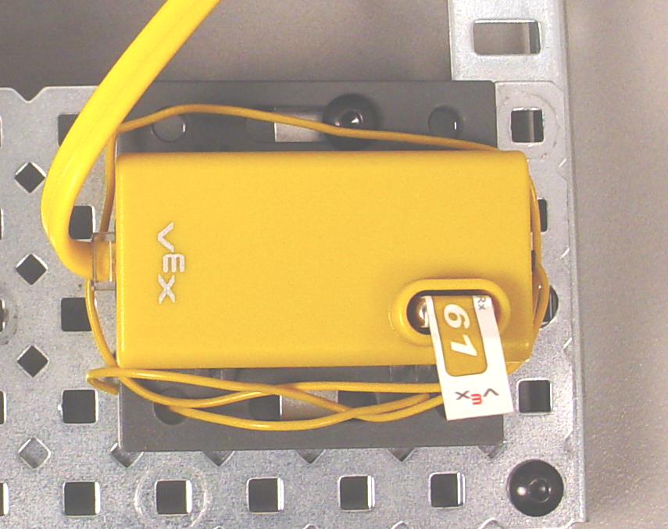
Receiver with matching crystal
Antenna wire on the receiver should be arranged as shown in figure one. If the antenna is fully distended the reception distance becomes difficult to measure.(it will be too large)
Vex controller
Battery (adequate charge)
One motor Fig. 1
Visual demonstration of motor output (ex. wheel turning, fan blades spinning)

Once the test system is complete the students can begin the investigation. In the first experiment, the team will explore the relationship between antenna height and signal strength. The hypothesis is that the transmission strength is a function of antenna height. Students will measure the distance from receiver at various antenna heights at a single position (with the transmitter antenna pointed at receiver) at signal failure.
- The starting position is about 4 feet from receiver
  - antenna is set at 4 inches and pointed at receiver
- Increase the distance from receiver (in a straight line) until the signal is lost.
  - Measure the distance from tip of the transmitting antenna to the receiver at signal failure (the motor stops).
- Repeat steps one and two increasing the antenna height by 4 inches each time up to an antenna height of 34 inches.
- Record data and graph results (antenna height verses failure distance) Students could use a variety of resources for generating the graphs. Using computer software such as Excel would be considered a plus.

In the second experiment, the team will compare the relationship between the antenna position and the strength of the signal. The hypothesis is that pointing the antenna at the receiver will not result in the best signal performance. Students will measure the distance from receiver at various antenna heights at a single position (with the transmitter antenna in a vertical position) at signal failure.
- The starting position is about 4 feet from receiver
  - antenna is set at 4 inches and vertical
- Increase the distance from receiver (in a straight line) until the signal is lost.
  - measure the distance from tip of the transmitting antenna to the receiver at signal failure (the motor stops)
- Repeat steps one, two and four (above) increasing the antenna height by 4 inches each time up to an antenna height of 34 inches.
- Record data and graph results (antenna height verses failure distance) Students could use a variety of resources for generating the graphs. (Using computer software such as Excel would be considered a plus).

In the final step of this investigation, the student will use a calculator with engineering notation (such as CASIO fx-300sa or the TI 83, 86, 89) to determine the frequency and time period of a sinusoidal wave form. In the first calculation the students are given a frequency and will calculate the time period given the following formula:

$$T=\frac{1}{f}$$
Where T is the time period and f is the frequency. The answer will be expressed in milliseconds, microseconds, or nanoseconds.
For the second calculation, the students are given a time period and will calculate the frequency given the following equation:

$$f=\frac{1}{T}$$
Where T is the time period and f is the frequency. The answer will be expressed in kilohertz, megahertz, or gigahertz.

The students will then gain an understanding of the sensitivity of a crystal.
- Given frequency of any two available Vex crystals, determine the difference between the 2 frequencies -express the answer in either megahertz or kilohertz.
- Calculate the time period of any two available Vex crystals, determine the difference between the 2 time periods -express the answer in nanoseconds.

If students are not familiar with units in engineering notation a review will be necessary.
See helper page Engineering Notation.

Procedure sheets for the students are included. Addition procedure sheets are included for further investigation.

Math versus Science
As students complete the investigations they will begin to understand the relationship between mathematics and science. Mathematics is pure; when you plug numbers into equations you will get the same result every time. Science is dependent on multiple variables that may or may not be in control of the investigator. A good scientist will eliminate as many uncontrollable variables as possible so that they are able to analyze and measure the results of their investigation.

Experimental Error
There are many things that can cause your experimentally measured numbers to fall off-target from the predicted values. Here are a few:

- Systematic error -Systematic error is something in the experiment that always throws off the data in the exact same way. Some examples of systematic errors are: dead battery, improperly connected components, defective motor.
- Random error -Random error is caused by small factors that constantly change and affect the experimental results. In this experiment, random error may be caused by varying starting points, sloppy measuring procedures, or battery level.

This investigation includes worksheets where students capture data and write conclusions. Below is some sample data presented in graph format using MS Excel.

