Lab Activity 2

Transmitter / Receiver Range Vertical Antenna Test Procedure sheet

Overview: Students will use the Vex Robotics System in a laboratory setting and conduct scientific inquiry-based experiments to determine the effect of transmitter antenna length in the vertical position on signal strength relative to the receiver.

In this Lesson, the student will be able to…

- Identify and measure the maximum distance from transmitter to receiver at various antenna heights at the vertical position (pointed at receiver)
- Use a fixed transmitter antenna height (4inches) and fixed transmitter distance from receiver to discover the optimal angle of the transmitter antenna
- Collect data from their investigation
- Apply and describe the various points of experimental procedure:
  - Experimental hypothesis
  - Measurement technique
  - Multiple trials
  - Systematic Error
  - Random Error
5. Write a summary describing what they learned in the investigation

Materials needed:
Constructed Robotic System
Radio Transmitter
Yard Stick
Tape Measure
Range Table 2 Datasheet

- Vertical Antenna Position Testing

2.1
Place Robotic System at a stationary point. Turn on VEX controller and radio.

2.2
Place radio in front of Robotic System upright and the antenna pointing towards the ceiling (Fig. 1). Extend the antenna 1” from the radio to gain minimal reception.
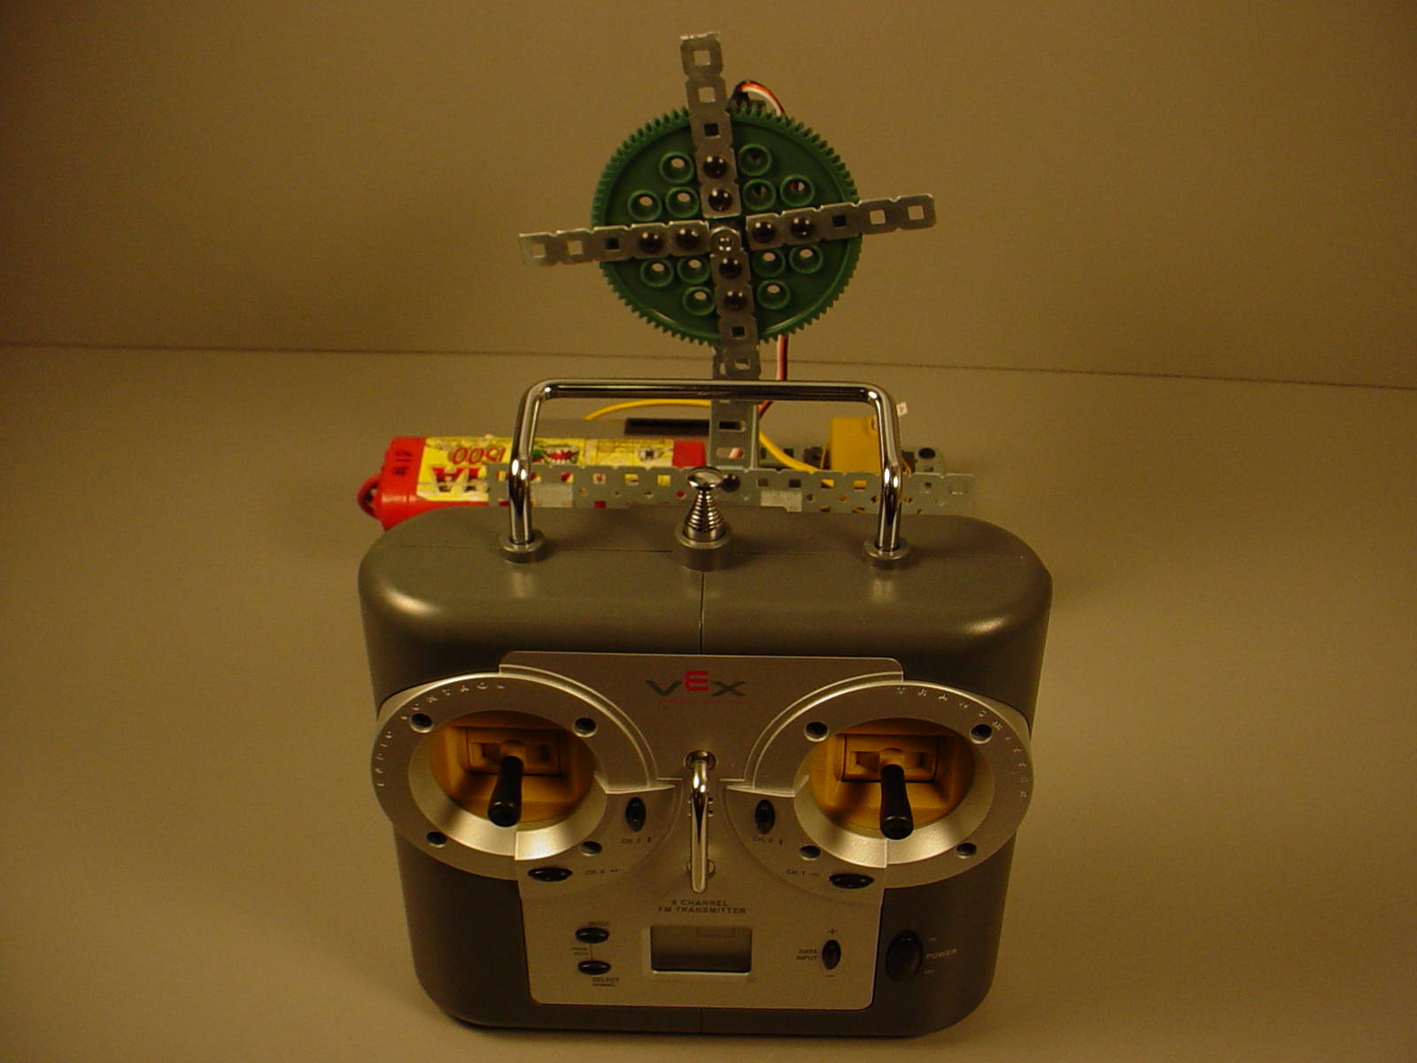

Fig. 1
2.3
Begin the experiment by pushing forward on the joystick of the radio to turn on the motor of the Robotic System. Keeping the radio as close as you can to the ground, and your finger on the joystick, slowly slide the radio away from the Robotic System until the motor stops moving. Once the motor has stopped, slowly slide the radio toward the Robotic System to regain the connection. Once you find a consistent signal at a maximum distance, measure from the antenna tip to the receiver antenna. Record the data in Table 2.

2.4
Using the yard stick, extend the antenna 4” from the radio (Fig. 2) and follow the same procedure in step 3 to find a consistent signal. Once you find a consistent signal at a maximum distance, measure from the antenna tip to the receiver antenna. Record the data in Table 2.

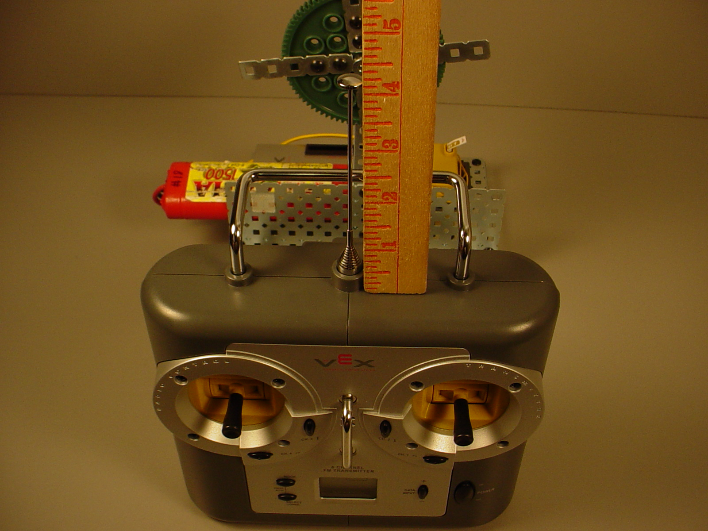
Fig. 2
2.5
Next, extend the antenna 8” from the radio and follow the same procedure in step 3 to find a consistent signal. Once you find a consistent signal at a maximum distance, measure from the antenna tip to the receiver antenna. Record the data in Table 2.

2.6
Continue to extend the antenna in 4” increments and measuring the distance from antenna tip to the receiver. Record the data in the packet at each increment. You will have 8 distances recorded in Table 2.

2.7
Complete graph comparison DataSheet.

2.8
Complete a reflection worksheet.

