Lab Activity 3

Transmitter / Receiver Range Waist High Test
Procedure sheet

Overview: Students will use the Vex Robotics System in a laboratory setting and conduct scientific inquiry-based experiments to determine the effect of transmitter antenna length at the waist high position on signal strength relative to the receiver.

In this Lesson, the student will be able to…

- Identify and measure the maximum distance from transmitter to receiver at various antenna heights at the waist high position (pointed at receiver)
- Use a fixed transmitter antenna height (4inches) and fixed transmitter distance from receiver to discover the optimal angle of the transmitter antenna
- Collect data from their investigation
- Apply and describe the various points of experimental procedure:
  - Experimental hypothesis
  - Measurement technique
  - Multiple trials
  - Systematic Error
  - Random Error
5. Write a summary describing what they learned in the investigation

Materials needed:
Constructed Robotic System
Radio Transmitter
Yard Stick
Tape Measure
Range Table 3 Datasheet

3.0 Waist High Radio Position Testing

3.1
Place Robotic System at a stationary point. Turn on VEX controller and radio.

3.2
Place the radio in front of Robotic System, waist high (approximately 2’ -3’), and the antenna between 45 degrees and vertical (Fig. 1). Extend the antenna 1” from the radio to gain minimal reception.
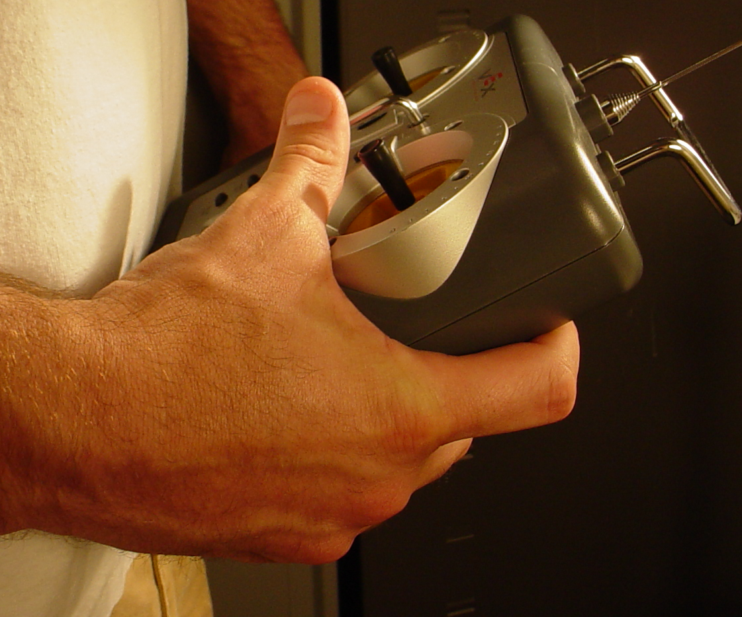
Fig. 1
3.3
Begin the experiment by pushing forward on the joystick of the radio to turn on the motor of the Robotic System. Keeping the radio at your waist, and your finger on the joystick, slowly walk away from the Robotic System until the motor stops moving. Once the motor has stopped, slowly walk toward the Robotic System to regain the connection. Once you find a consistent signal at a maximum distance, measure from the antenna tip to the receiver antenna. Record the data in Table 3.

3.4
Using the yard stick, extend the antenna 4” from the radio (Fig. 2) and follow the same procedure in step 3 to find a consistent signal. Once you find a consistent signal at a maximum distance, measure from the antenna tip to the receiver antenna. Record the data in Table 3.
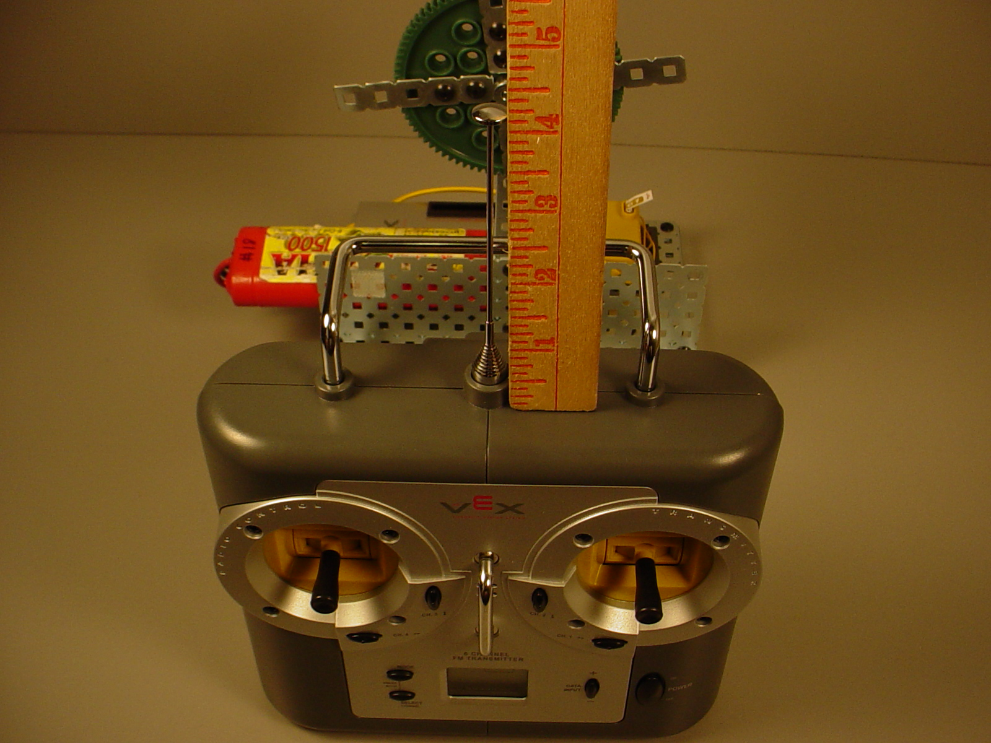
Fig. 2

3.5
Next, extend the antenna 8” from the radio and follow the same procedure in step 3 to find a consistent signal. Once you find a consistent signal at a maximum distance, measure from the antenna tip to the receiver antenna. Record the data in Table 3.

3.6
Continue to extend the antenna in 4” increments and measuring the distance from antenna tip to the receiver. Record the data in the packet at each increment. You will have 8 distances recorded in Table 3.

3.7

Complete graph comparison DataSheet.

3.7

Complete a reflection worksheet.

