Lab Activity 4

Transmitter / Receiver Range Test with Obstacles
Procedure sheet

Overview: Students will use the Vex Robotics System in a laboratory setting and conduct scientific inquiry-based experiments to determine the effect of transmitter signal strength relative to an obstructed receiver.

In this Lesson, the student will be able to…

- Identify and measure the maximum distance from transmitter to an obstructed receiver at the waist high position (pointed at receiver)
- Use a fixed transmitter antenna height (34 inches) to discover the maximum distance and the optimal angle of the transmitter antenna
- Collect data from their investigation
- Apply and describe the various points of experimental procedure:
  - Experimental hypothesis
  - Measurement technique
  - Multiple trials
  - Systematic Error
  - Random Error
5. Write a summary describing what they learned in the investigation

Materials needed:
Constructed Robotic System
Radio Transmitter
Tape Measure
Sheet of Paper, Wood, Sheet Metal
Range Table 4 Datasheet

4.0 Waist High Radio Position Testing with Obstacles

4.1
Place Robotic System at a stationary point. Turn on VEX controller and radio.

4.2
Place the radio in front of Robotic System, waist high (approximately 2’ -3’), and the antenna between 45 degrees and vertical (Fig. 1). Make sure antenna is fully extended from the radio.
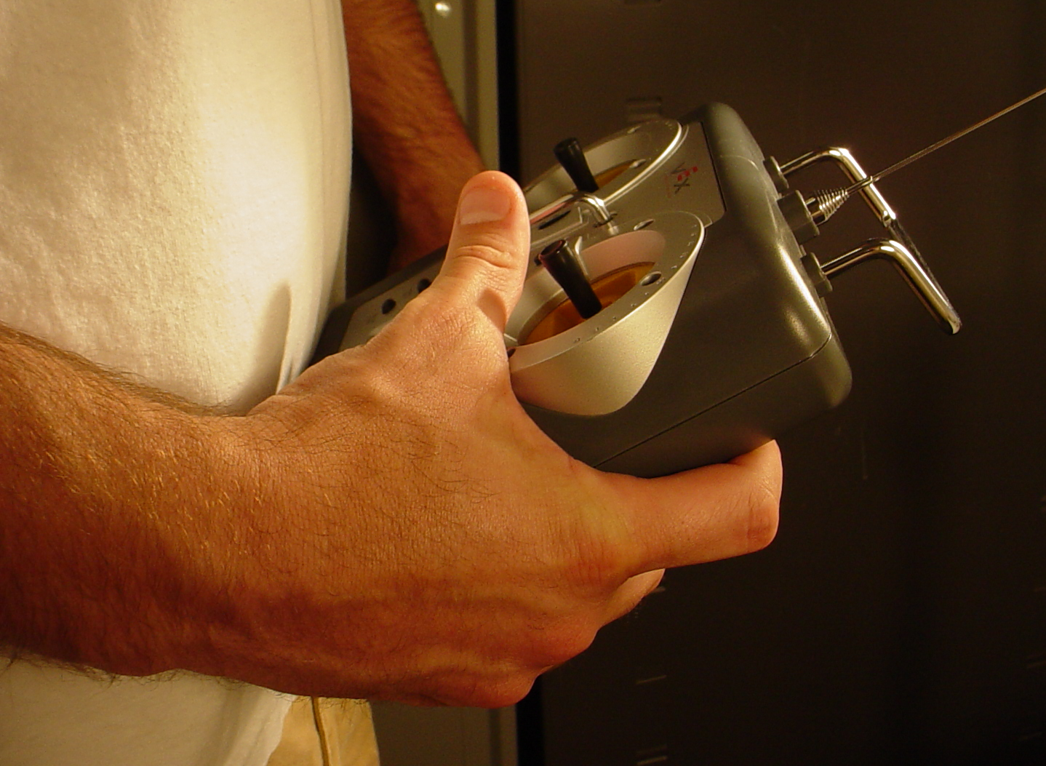
Fig. 1
4.3
Begin the experiment by placing a piece of paper on top of the receiver and the antenna (Fig. 2). Make sure the antenna wire is not in the plastic tube and is wrapped around the receiver. Push forward on the joystick of the radio to turn on the motor of the Robotic System. Keeping the radio at your waist, and your finger on the joystick, slowly walk away from the Robotic System until the motor stops moving. Once the motor has stopped, slowly walk toward the Robotic System to regain the connection. Once you find a consistent signal at a maximum distance, measure from the antenna tip to the receiver antenna. Record the data in Table 4.

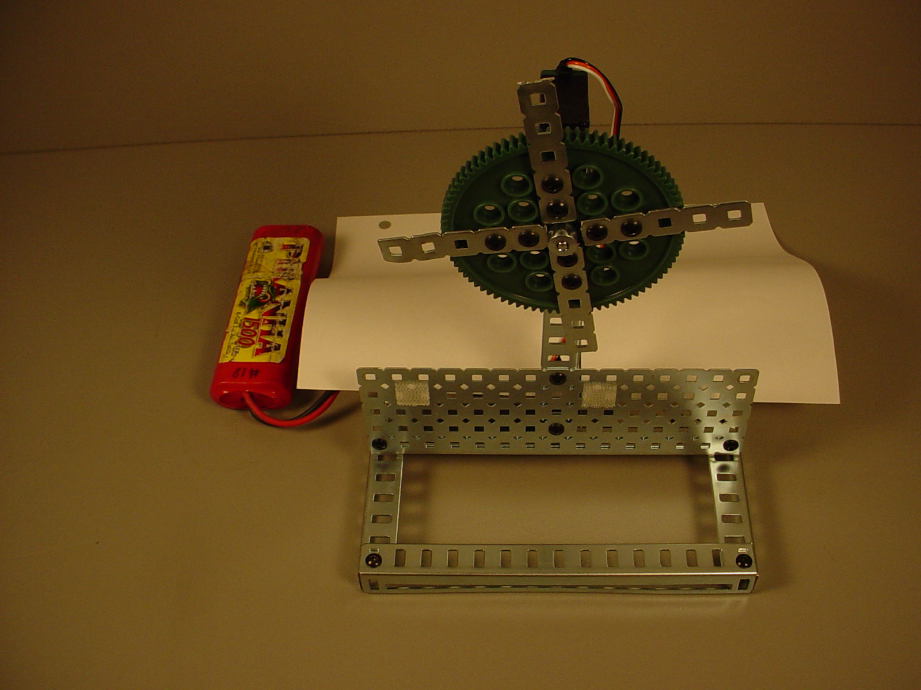
Fig. 2

4.4
Next, place a piece of wood on top of the receiver and the antenna (Fig. 3). Make sure the antenna wire is not in the plastic tube and is wrapped around the receiver. Push forward on the joystick of the radio to turn on the motor of the Robotic System. Keeping the radio at your waist, and your finger on the joystick, slowly walk away from the Robotic System until the motor stops moving. Once the motor has stopped, slowly walk toward the Robotic System to regain the connection. Once you find a consistent signal at a maximum distance, measure from the antenna tip to the receiver antenna. Record the data in Table 4.
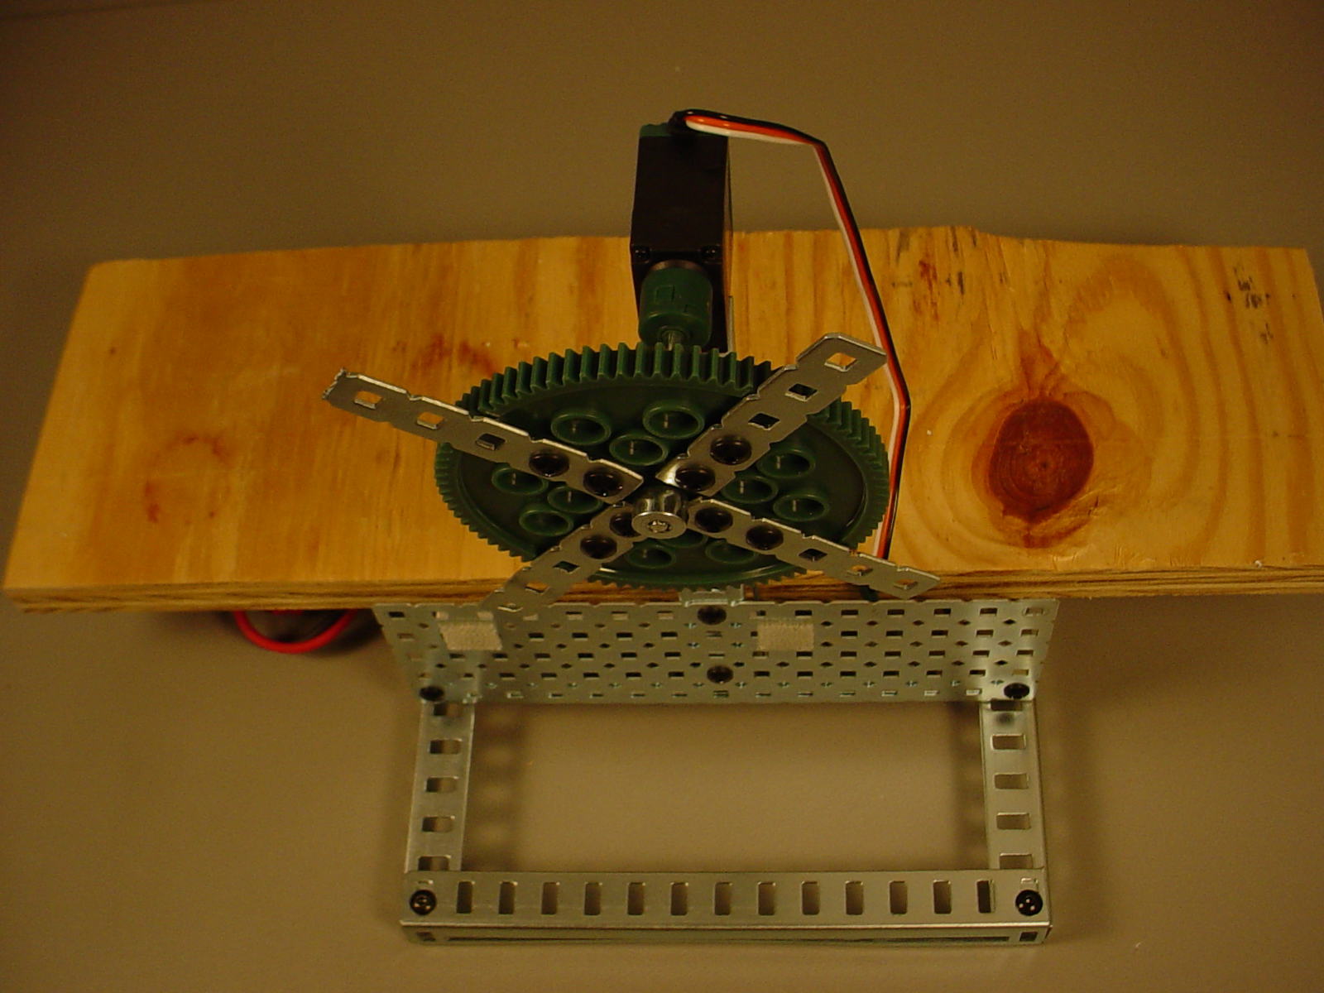
Fig. 3

4.5
Finally, place a piece of Sheet Metal on top of the receiver and the antenna (Fig. 4). Make sure the antenna wire is not in the plastic tube and is wrapped around the receiver. Push forward on the joystick of the radio to turn on the motor of the Robotic System. Keeping the radio at your waist, and your finger on the joystick, slowly walk away from the Robotic System until the motor stops moving. Once the motor has stopped, slowly walk toward the Robotic System to regain the connection. Once you find a consistent signal at a maximum distance, measure from the antenna tip to the receiver antenna. Record the data in Table 4.

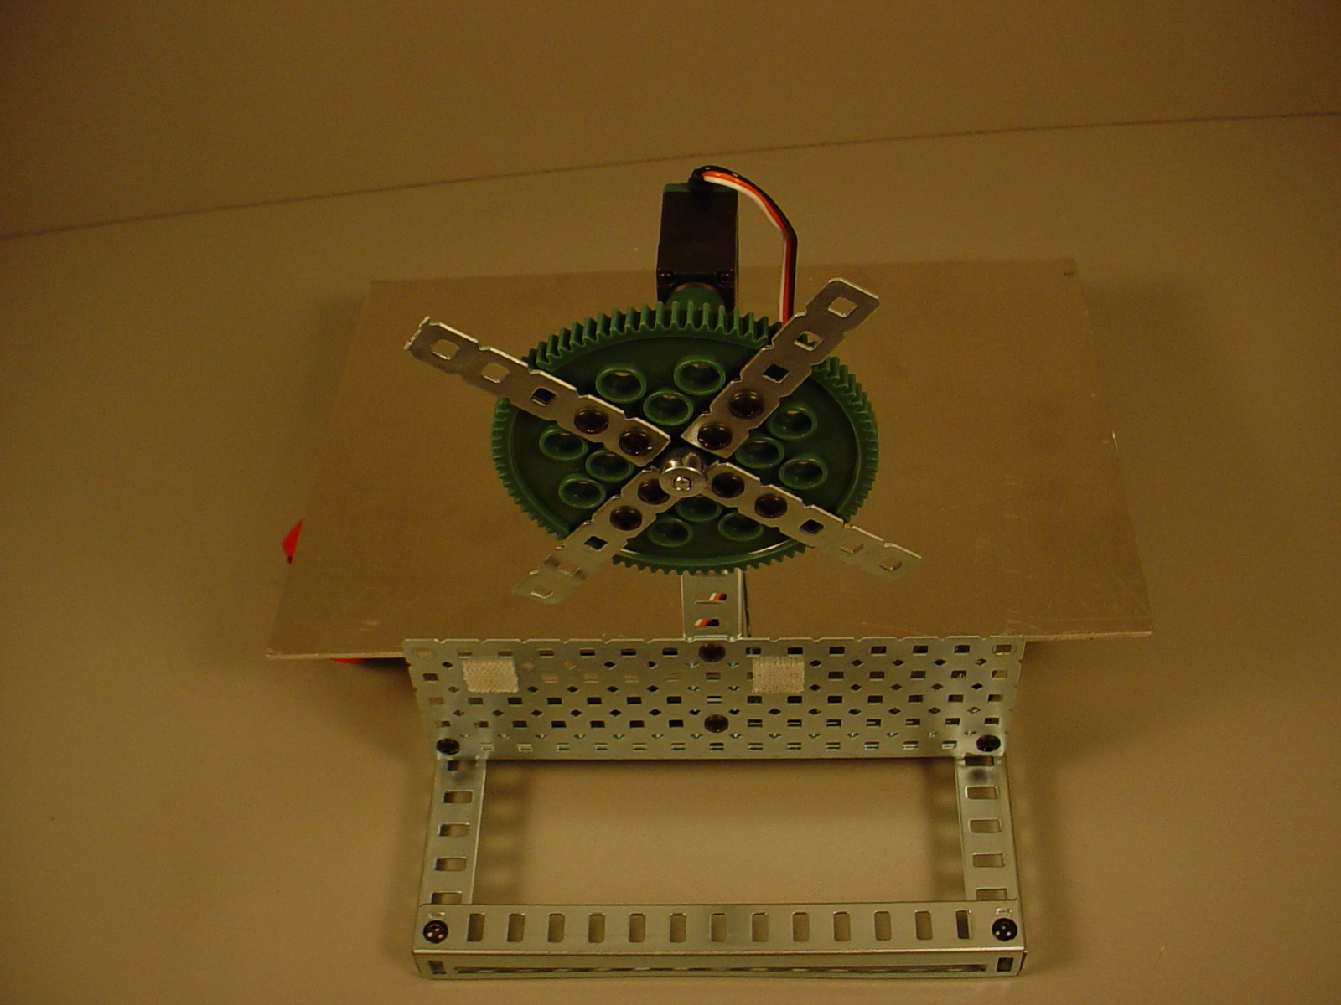
Fig. 4

4.6
Complete graph comparison DataSheet.

4.7
Complete a reflection worksheet

