Game Board Building Instructions

The game table for your camp will be a standard size from year to year. It is the same size as the FLL game table that many of you are familiar with.

MATERIALS
Material | Quantity
plywood, 96” X 48” X 1/2” or thicker | 1
One 4’X8’ piece of white board (melamine) | 1
two-by-four, 8’ | 3
two-by-three, 8’ | 2
black paint | 1 pt. or spray can
coarse drywall screws, 6 X 2-1/2” | 1/2 lb.

TOOLS
safety goggles
cross cut saw
Phillips-head screw driver (power preferable)
tape measure & pencil
two 6” clamps
level
paint brush (unless you’re using a spray can)

PARTS
Part | Make From | Dimensions | Paint | Quantity
table surface | plywood | 96” X 48” | no | 1
large Field Border | two-by-four | 96” | yes | 2
small Field Border | two-by-four | 45” | yes | 2
Stiffener | two-by-three | 48” | no | 4

Assembly

Step 1)
Decide which face of the plywood is least smooth, and consider that the bottom face.
On the bottom face, locate, clamp, and screw on the stiffeners as shown in Figure 1.

Step 2)
On the top face of the plywood, locate and clamp the framework of Field Borders around the perimeter as shown in Figure 2. Double check that the 93” and 45” wall-to-wall inside distances are within ± 1/8” and trim or gap as needed until the tolerance is achieved. Then screw on the borders.

Step 3)
The table is not designed to support the weight of a person---DO NOT STAND ON THE TABLE. Center, clamp, level, and screw the uprights onto the outside face of the small Field Borders as shown in Figure 4. Be sure each joint is strong. With the help of another person, situate the cross beam on top of the two uprights and screw it down. Hang the shop light by its chains from the center of the cross beam.

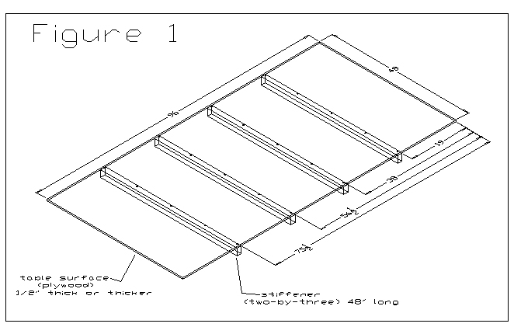

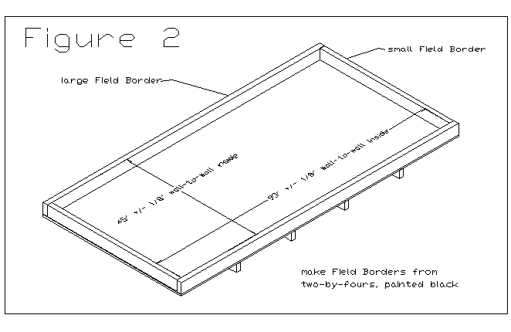
Last step- Cut three inches off of the end and the side of a piece of 4’x8’ white board which will be dropped into the game table and will serve as the surface where everything will be taped to.

This board fits into the playing table.
44.5”
92.5”

